**EXPERIMENT 9**

**AIM** - Study of simple and complex view

**Source code**

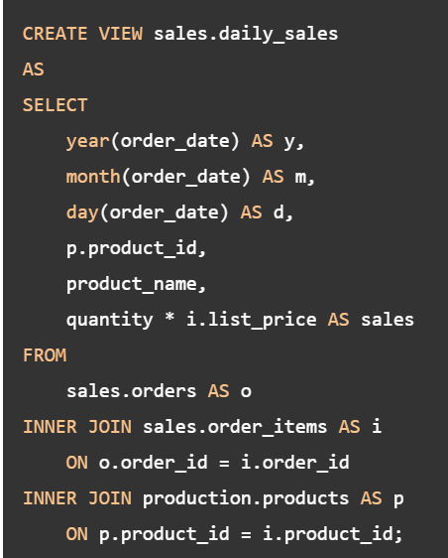

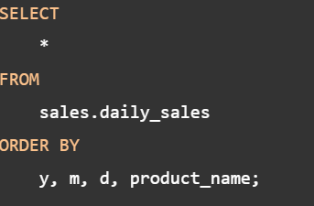

(Shristi Yadav 21SCSE1011202)

**OUTPUT**

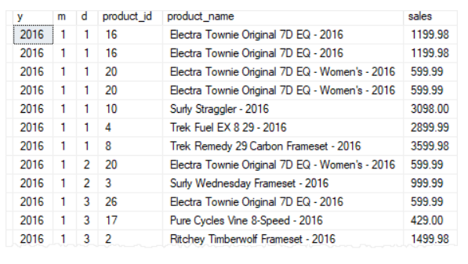

**SELECTING A DATA SET FROM VIEW**

**SOURCE CODE-**

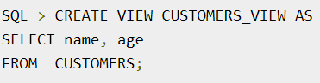



**OUTPUT-**

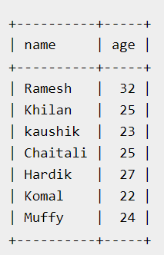

(Shristi Yadav 21SCSE1011202)

**DESTROYING A VIEW-**

**SOURCE CODE**



(Shristi Yadav 21SCSE1011202)

**EXPERIMENT 10**

**AIM-** PL/SQL program for addition of two numbers

SOURCE CODE

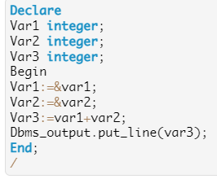

OUTPUT

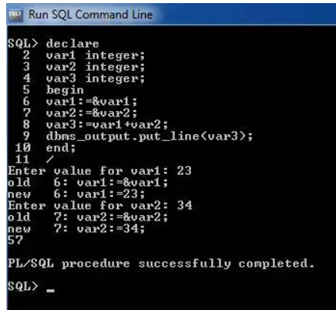

(Shristi Yadav 21SCSE1011202)